SQL_Views Assignment

Note: This assignment has to be completely performed in MYSQL Workbench. Select your OS type and download workbench from the given link. https://dev.mysql.com/downloads/workbench/

The version of MYSQL Workbench used for this assignment is 8.0.27
You can use any other stable version.
Follow: https://youtu.be/YSOY_NyOg40

- Views in SQL are kind of virtual tables. A View can either have all the rows of a table or specific rows based on certain condition.

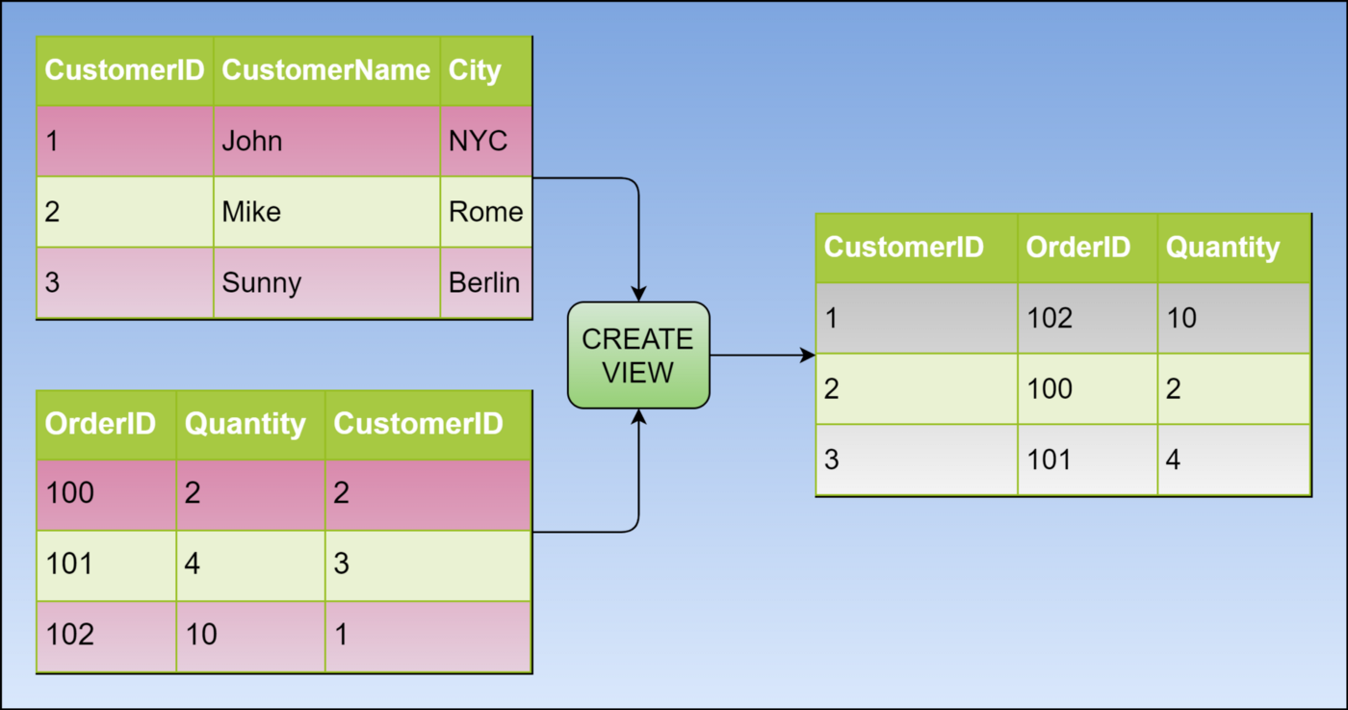

SCHEMA
EVENTS TABLE PARTICIPANT TABLE
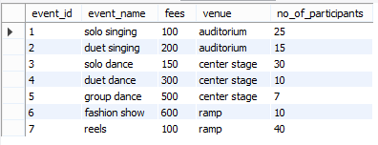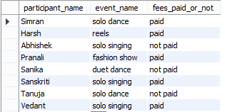

Before beginning, lets first create a table and insert data.
Create table ‘events’ having columns event_id,event_name,fees,venue,no_of_participants

This is how our events table should look like
.
EVENTS TABLE


CREATING VIEWS

We can create View using CREATE VIEW statement. A View can be created from a single table or multiple tables.

Syntax:

CREATE VIEW view_name AS
SELECT column1, column2.....
FROM table_name
WHERE condition;

view_name: Name for the View
table_name: Name of the table
condition: Condition to select rows

Creating View from a single table:

CREATE VIEW DetailsView AS
SELECT NAME, ADDRESS
FROM StudentDetails
WHERE S_ID < 5;

Q1. Create a view having event name and venue for events having more than 10 participants and venue as center stage.

YOUR QUERY HERE:
create view q1 as select event_name,venue from events where no_of_participants>10 and venue='center stage';
select * from q1;
Output:
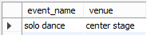

Q2. Create a view having event name and venue for events having venue as auditorium.

YOUR QUERY HERE:
create view q2 as select event_name,venue from events where venue='auditorium';
select * from q2;

Output:
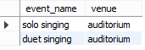

Creating View from multiple tables:

CREATE VIEW MarksView AS
SELECT StudentDetails.NAME, StudentDetails.ADDRESS, StudentMarks.MARKS
FROM StudentDetails, StudentMarks
WHERE StudentDetails.NAME = StudentMarks.NAME;

For creating views from multiple tables, lets create a second table and insert data.
Create table ‘participant’ having columns, participant_name,event_name, ,fees_paid_or_not

This is how our schema should look like.

PARTICIPANT TABLE


Q3. Create a view from events and participant tables having matching event names.

YOUR QUERY HERE:
create view q3 as select participants.even_name,participant_name from events,participants where events.event_name=participants.even_name;
select * from q3;

Output:
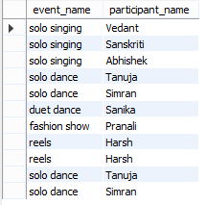

Q4. Create a view of event name and participant name participating in solo singing event.

YOUR QUERY HERE:
create view q3 as select participants.even_name,participant_name from events,participants where events.event_name=participants.even_name;
select * from q3 where event_name='solo singing';

Output:
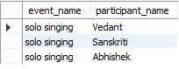

DELETING VIEWS

Syntax:

DROP VIEW view_name;

Q5. Delete the view3.
YOUR QUERY HERE:
drop view q3;
select * from q3 ;
Output:

UPDATING VIEWS

- The SELECT statement which is used to create the view should not include GROUP BY clause or ORDER BY clause.
- The SELECT statement should not have the DISTINCT keyword.
- The View should have all NOT NULL values.
- The view should not be created using nested queries.
- The view should be created from a single table.

We can use the CREATE OR REPLACE VIEW statement to add or remove fields from a view.
Syntax:
CREATE OR REPLACE VIEW view_name AS
SELECT column1,coulmn2,..
FROM table_name
WHERE condition;

Q6. Replace the view2 with participant names who have not paid the fees.

YOUR QUERY HERE:
create or replace view q2 as select participant_name,fees_paid_or_not_paid from participants where fees_paid_or_not_paid='not paid';
select * from q2 ;
Output:

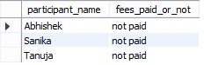

Inserting a row in a view:

Syntax:
INSERT INTO view_name(column1, column2 , column3,..) VALUES(value1, value2, value3..);
Q7. Insert a row of values in the view2.
YOUR QUERY HERE:
insert into q2 values('Nitish','not paid');
select * from q2 ;
Output:
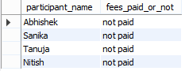

Congratulations, you have just completed an assignment!!


FEEDBACK FORM:

https://docs.google.com/forms/d/e/1FAIpQLScnAaAKvph9R3vINyCtOOMiav-tSMsRGlJReMaHyPjsXDlTIA/viewform

